Chapter 5

Implementation

Introduction:
Implementation includes all activities those take place to convert from old system to the new one. The new system may be totally new, replacing an existing manual or automated system, or it may be major modification to an existing system. In either case proper implementation is essential to provide a reliable system to meet organization requirements successful implementation but may not guarantee improvement in the organization using new system.

  - Implementation Environment
For Implementation we have used:
- XCode 4.5.2
- iPhone Simulator 5.0 or higher
- Metaio Creator
- iOS SDK 5.0 or higher
- Metaio ToolBox
- SmartSVN 7.5.3

GUI based Vs. Non GUI
In GUI based application it is very easy for user to understand the overall content and the previous and next step of the action. Also GUI based application does not make as issues like navigation, ambiguities in data selection and entry.
GUIs have become the established alternative to traditional forms-based user interfaces. GUIs are the assumed user interface for virtually all the systems development using modern technologies. There are several reasons why GUIs have become so popular.
- GUIs provide the standard look and feel of a client operating system.
- GUIs are so flexible that they can be used in most application areas.
- The GUI provides seamless integration of custom and package applications.
- The user has a more natural interface to applications: user understanding is improved.
Table 6.1.1 Comparison between GUI and NON-GUI

GUI | NON GUI
In GUI based there is no hierarchical ordering of forms. | In Non GUI based applications, the forms are arranged in a hierarchical order.
The most obvious characteristic of GUI application it allows multiple windows to be displayed at the same time. | With Non GUI based application we can interact with one form at a time.
There are no constraints on the order in which user may enter data on screen. | In Non GUIs, the fields on the form have a predefined and unchangeable, the user may only access the fields in a certain order, regardless of whether any data has been entered into the form fields.
GUI introduces additional objects such as radio buttons, scrolling lists, check boxes and other graphics that may be displayed or directly manipulated. | Non GUI based do not have such objects.

Table 6.1.2 Comparison between Single user and Multi User

Single User | Multi User
The major disadvantage is that when one user is accessing a system other user cannot use it. | Multiple users can access the system paralleled.

Our system is mobile-app GUI and single-user system so no parallel access of the system will be there.
In our system all connections with database is not done by the process of designing. There is proper and efficient coding for connection with database.

  - Technology and Literature Review

    - XCode (4.5.2)
Xcode is an Integrated Development Environment (IDE) containing a suite of software development tools developed by Apple for developing software for OS X and iOS. First released in 2003, the latest stable release is version 4.6 and is available via the Mac App Store free of charge for Mac OS X Lion and OS X Mountain Lion users. Registered developers can download preview releases and previous versions of the suite through the Apple Developer website.
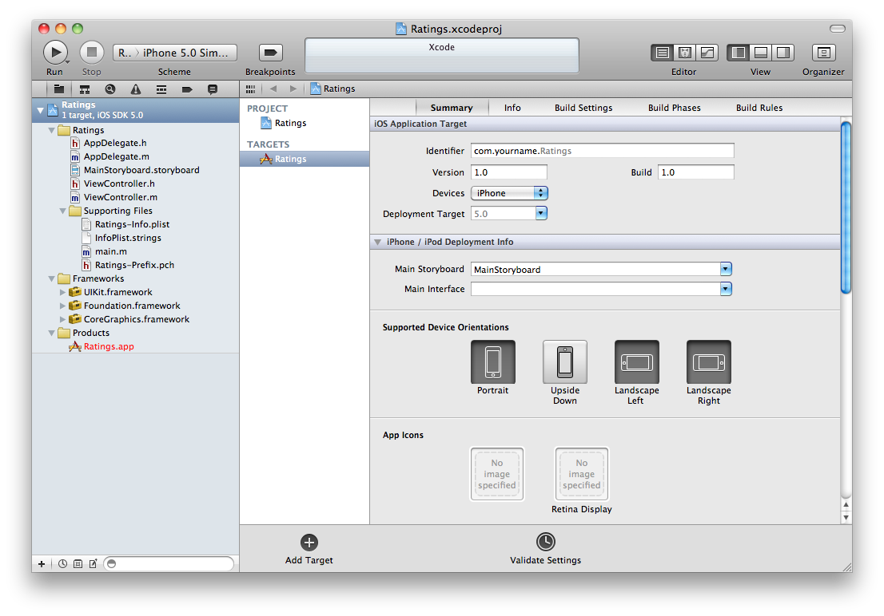
figure::::
The main application of the suite is the integrated development environment (IDE), also named Xcode. The Xcode suite also includes most of Apple's developer documentation, and built-in Interface Builder, an application used to construct graphical user interfaces.
The Xcode suite includes a modified version of the GNU Compiler Collection as well as, in Xcode 3.1 and later, the llvm-gcc compiler, with front ends from the GNU Compiler Collection and a code generator based on LLVM, and, in Xcode 3.2 and later, Apple's LLVM Compiler, with the clang front end and a code generator based on LLVM, and the Clang Static Analyzer. It supports C, C++, Objective-C, Objective-C++, Java, AppleScript, Python and Ruby source code with a variety of programming models, including but not limited to Cocoa, Carbon, and Java. Third parties have added support for GNU Pascal, Free Pascal , Ada , C# , Perl , and D. The Xcode suite used the GNU Debugger as the back-end for its debugger. As of version 4.2 the Apple LLVM Compiler became the default compiler. LLDB became the default debugger as of Xcode 4.3.

    - Metaio Creator
Metaio Creator 2.5 is a very easy to use Augmented Reality authoring tool that allows the creation of Augmented Reality scenarios based on the latest tracking technology with all kinds of content and deployment options. It allows an easy configuration of all related tasks and seamlessly connects to the metaiocloud.
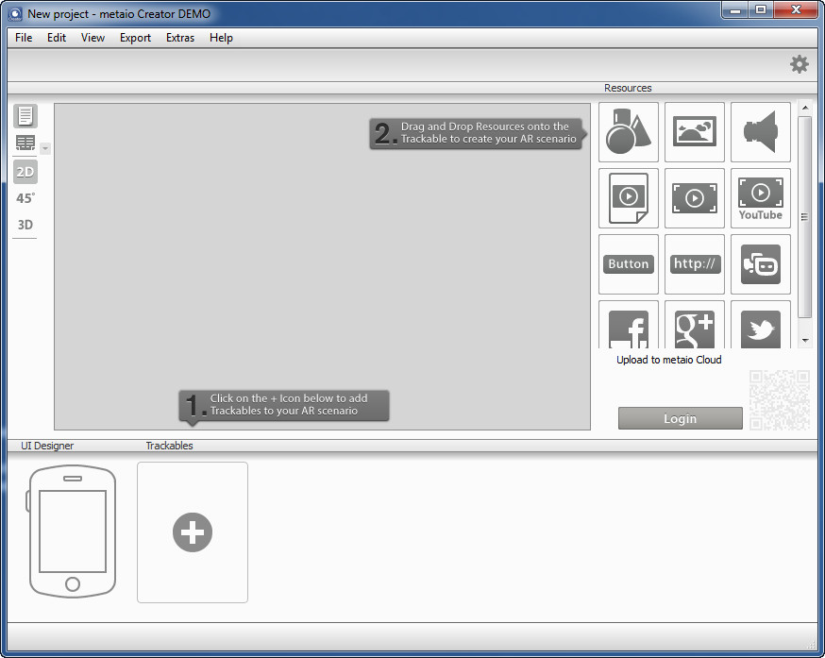
figure::::
    - Metaio ToolBox
Metaio Toolbox is our iOS-based application, empowering you to create 3D tracking maps of all textured objects in your surrounding. Using Toolbox, you will have a smooth experience for two mapping techniques. You can further use your created maps in metaio mobile SDK, through junaio or loading it to the metaio Creator to build your own AR-application.
Download Toolbox from the link to the Appstore on the right column of this document and get ready to choose the best mapping approach matching your scenario. The current version of Toolbox is aimed at devices with iOS 5 or higher. Below you see a snapshot from the main page in Toolbox.
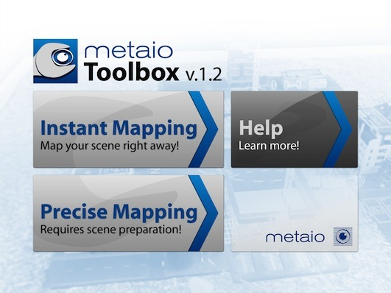

Figure :

    - iOS
iOS (previously iPhone OS) is a mobile operating system developed and distributed by Apple Inc. Originally released in 2007 for the iPhone and iPod Touch, it has been extended to support other Apple devices such as the iPad and Apple TV. Unlike Microsoft's Windows Phone (C++) and Google's Android, Apple does not license iOS for installation on non-Apple hardware. As of September 12, 2012, Apple's App Store contained more than 700,000 iOS applications, which have collectively been downloaded more than 30 billion times. In June 2012, it accounted for 65% of mobile web data consumption (including use on both the iPod Touch and the iPad). At the half of 2012, there were 410 million devices activated.
The user interface of iOS is based on the concept of direct manipulation, using multi-touch gestures. Interface control elements consist of sliders, switches, and buttons. Interaction with the OS includes gestures such as swipe, tap, pinch, and reverse pinch, all of which have specific definitions within the context of the iOS operating system and its multi-touch interface. Internal accelerometers are used by some applications to respond to shaking the device (one common result is the undo command) or rotating it in three dimensions (one common result is switching from portrait to landscape mode).
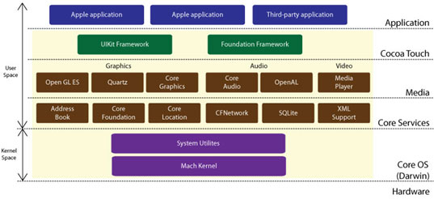Figure :
iOS is derived from OS X, with which it shares the Darwin foundation. iOS is Apple's mobile version of the OS X operating system used on Apple computers.
In iOS, there are four abstraction layers: the Core OS layer, the Core Services layer, the Media layer, and the Cocoa Touch layer. The current version of the operating system (iOS 6.1.2) dedicates 1-1.5 GB of the device's flash memory for the system partition, using roughly 800 MB of that partition (varying by model) for iOS itself.
iOS currently runs on iPhone, iPad, iPod touch and Apple TV.

  - Modules Specification
The “vCamView” Mobile Application uses objective c classes along with xib files for GUI design. We have also used Metaio SDK. To transfer data between files we have used core data framework . We have also used xml and plist files for implementation.It is stand alone application which is not dependent on any webservies.

Module performs following tasks :
- Detection of object.
- Configure the object.
- Edit object information.
- Settings of application.
- Social media sharing.

  - Coding Standards
    - General Principles
- Clarity
It is good to be both clear and brief as possible, but clarity shouldn’t suffer because of brevity:

Example:
insertObject:atIndex: | Good.
insert:at: | Not clear; what is being inserted? what does “at” signify?

- Consistency
Try to use names consistently throughout the Cocoa programmatic interfaces. If you are unsure, browse the current header files or reference documentation for precedents.

Consistency is especially important when you have a class whose methods should take advantage of polymorphism. Methods that do the same thing in different classes should have the same name.

Example :
(NSInteger)tag | Defined in NSView, NSCell, NSControl.
- (void)setStringValue:(NSString *) | Defined in a number of Cocoa classes.

- Class and protocol names
The name of a class should contain a noun that clearly indicates what the class (or objects of the class) represent or do. The name should have an appropriate prefix (see “Prefixes”). The Foundation and application frameworks are full of examples; a few are NSString, NSDate, NSScanner, NSApplication, UIApplication, NSButton, and UIButton.
Protocols should be named according to how they group behaviors:
Most protocols group related methods that aren’t associated with any class in particular. This type of protocol should be named so that the protocol won’t be confused with a class. A common convention is to use a gerund (“...ing”) form:

NSLocking | Good.
NSLock | Poor (seems like a name for a class).

Some protocols group a number of unrelated methods (rather than create several separate small protocols). These protocols tend to be associated with a class that is the principal expression of the protocol. In these cases, the convention is to give the protocol the same name as the class.
An example of this sort of protocol is the NSObject protocol. This protocol groups methods that you can use to query any object about its position in the class hierarchy, to make it invoke specific methods, and to increment or decrement its reference count. Because the NSObject class provides the primary expression of these methods, the protocol is named after the class.

    - Methods

- Accessor Methods
Accessor methods are those methods that set and return the value of a property of an object. They have certain recommended forms, depending on how the property is expressed:

If the property is expressed as a noun, the format is:
- (type)noun;
- (void)setNoun:(type)aNoun;

For example:

- (NSString *)title;
- (void)setTitle:(NSString *)aTitle;

If the property is expressed as an adjective, the format is:

- (BOOL)isAdjective;
- (void)setAdjective:(BOOL)flag;

For example:

- (BOOL)isEditable;
- (void)setEditable:(BOOL)flag;

- Delegate Methods
Delegate methods (or delegation methods) are those that an object invokes in its delegate (if the delegate implements them) when certain events occur. They have a distinctive form, which apply equally to methods invoked in an object’s data source:

Start the name by identifying the class of the object that’s sending the message:

- (BOOL)tableView:(NSTableView *)tableView shouldSelectRow:(int)row;
- (BOOL)application:(NSApplication *)sender openFile:(NSString *)filename;
The class name omits the prefix and the first letter is in lowercase.
A colon is affixed to the class name (the argument is a reference to the delegating object) unless the method has only one argument, the sender.

- (BOOL)applicationOpenUntitledFile:(NSApplication *)sender;

- Method arguments
There are a few general rules concerning the names of method arguments:

- As with methods, arguments start with a lowercase letter and the first letter of successive words are capitalized (forexample, removeObject:(id)anObject).
- Don’t use “pointer” or “ptr” in the name. Let the argument’s type rather than its name declare whether it’s a pointer.
- Avoid one- and two-letter names for arguments.=
- Avoid abbreviations that save only a few letters.

    - Functions
Objective-C allows you to express behavior through functions as well as methods. You should use functions rather than, say, class methods, when the underlying object is always a singleton or when you are dealing with obviously functional subsystems.

Functions have some general naming rules that you should follow:
Function names are formed like method names, but with a couple exceptions:

  - They start with the same prefix that you use for classes and constants.
  - The first letter of the word after the prefix is capitalized.

Most function names start with verbs that describe the effect the function has:
NSHighlightRect
NSDeallocateObject

Functions that query properties have a further set of naming rules:
If the function returns the property of its first argument, omit the verb.

unsigned int NSEventMaskFromType(NSEventType type)
float NSHeight(NSRect aRect)

If the value is returned by reference, use “Get”.
const char *NSGetSizeAndAlignment(const char *typePtr, unsigned int *sizep, unsigned int *alignp)

If the value returned is a boolean, the function should begin with an inflected verb.
BOOL NSDecimalIsNotANumber(const NSDecimal *decimal)

    - Properties
A declared property effectively declares accessor methods for a property, and so conventions for naming a declared property are broadly the same as those for naming accessor methods. If the property is expressed as a noun or a verb, the format is:
@property (…) type nounOrVerb;
Example :
@property (strong) NSString *title;
@property (assign) BOOL showsAlpha;

If the name of a declared property is expressed as an adjective, however, the property name omits the “is” prefix but specifies the conventional name for the get accessor, for example:
@property (assign, getter=isEditable) BOOL editable;

In many cases, when you use a declared property you also synthesize a corresponding instance variable.
Make sure the name of the instance variable concisely describes the attribute stored. Usually, you should not access instance variables directly; instead you should use accessor methods (you do access instance variables directly in init and dealloc methods). To help to signal this, prefix instance variable names with an underscore (_), for example:
@implementation MyClass {
BOOL _showsTitle;
}

@implementation MyClass
@synthesize showsTitle=_showsTitle;

If you synthesize the instance variable using a declared property, specify the name of the instance variable in the @synthesize statement.
There are a few considerations to keep in mind when adding instance variables to a class:

Avoid explicitly declaring public instance variables.
Developers should concern themselves with an object’s interface, not with the details of how it stores its data. You can avoid declaring instance variables explicitly by using declared properties and synthesizing the corresponding instance variable.
  - If you need to declare an instance variable, explicitly declare it with either @private or @protected.
If you expect that your class will be subclassed, and that these subclasses will require direct access to the data, use the @protected directive.
  - If an instance variable is to be an accessible attribute of instances of the class, make sure you write accessor methods for it (when possible, use declared properties).

